Part1 on View:

1-1) Create a view named VDept_Budget that reports headcount for each department.

The report includes 3 columns as follow:

Dept_Name, Dept_Number, No_Emp.

Include all the departments.

Show the content of the view through SQL (Select * from VDept_Budget;)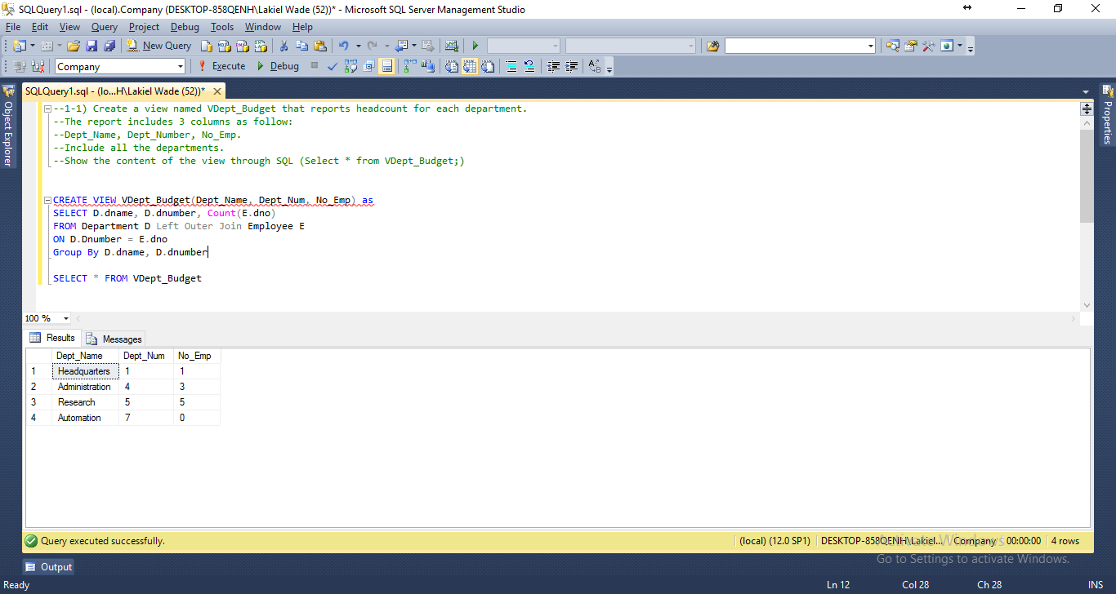

1-2) Add yourself to the database (to Employee table). Then Show the content of your view again to see if your view is updated according to the changes in its base table Employee.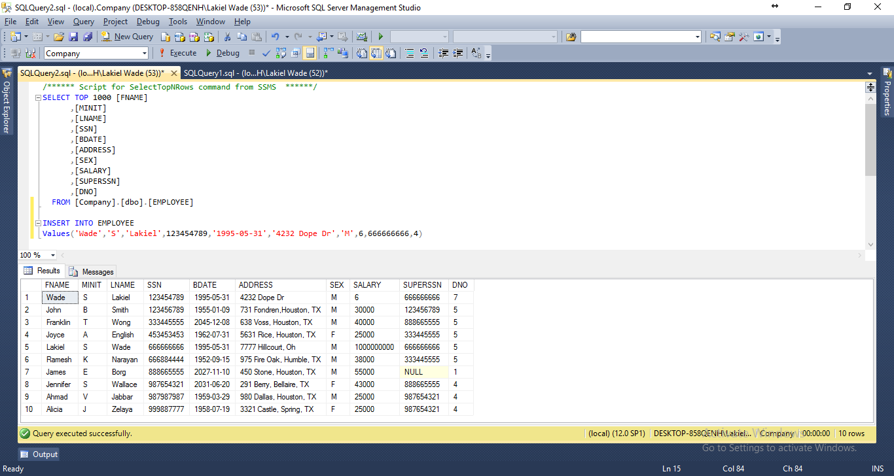

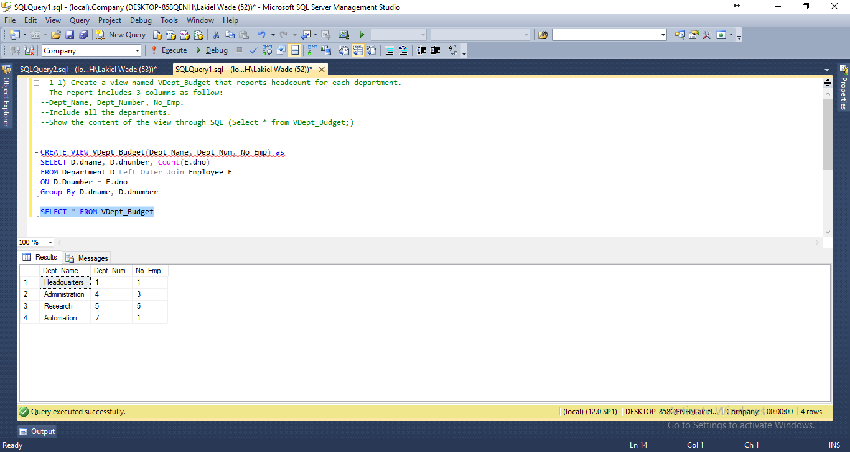

1-3) Then Change your view to add two more info – Sum_Salary, Ave_Salary for each department. Include all the departments. Your report (view) lists 5 Columns as follow: Dept_Name, Dept_Number, No_Emp, Sum_Salary, Ave_Salary

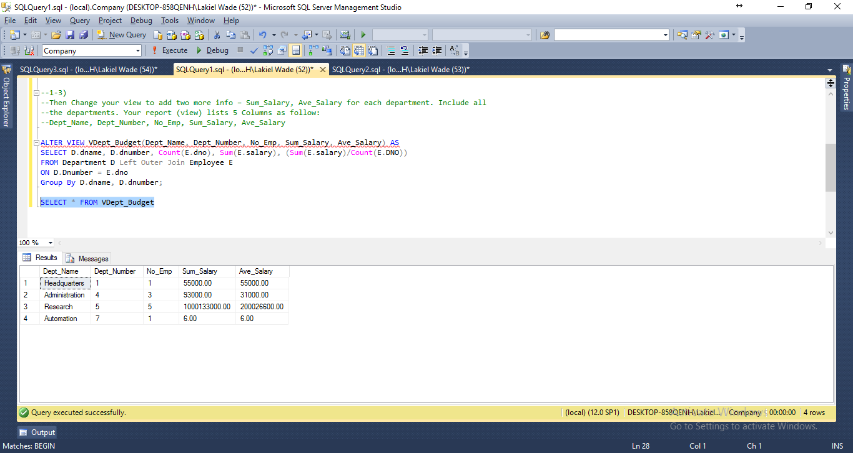

Part 2

